School of Computer Science and Artificial Intelligence

Lab Assignment # 8.2

Program | : B. Tech (CSE)
Course Title | : AI Assisted
Coding Course Code : 23CS002PC304
Semester : VI
Academic Session : 2025-2026
Name of Student : M.sriram
Enrollment No. : 2303A52165
Batch No. : 34
Date : 10/02/26

Even/Odd Number Validator
Step 1: Test Cases (written first)
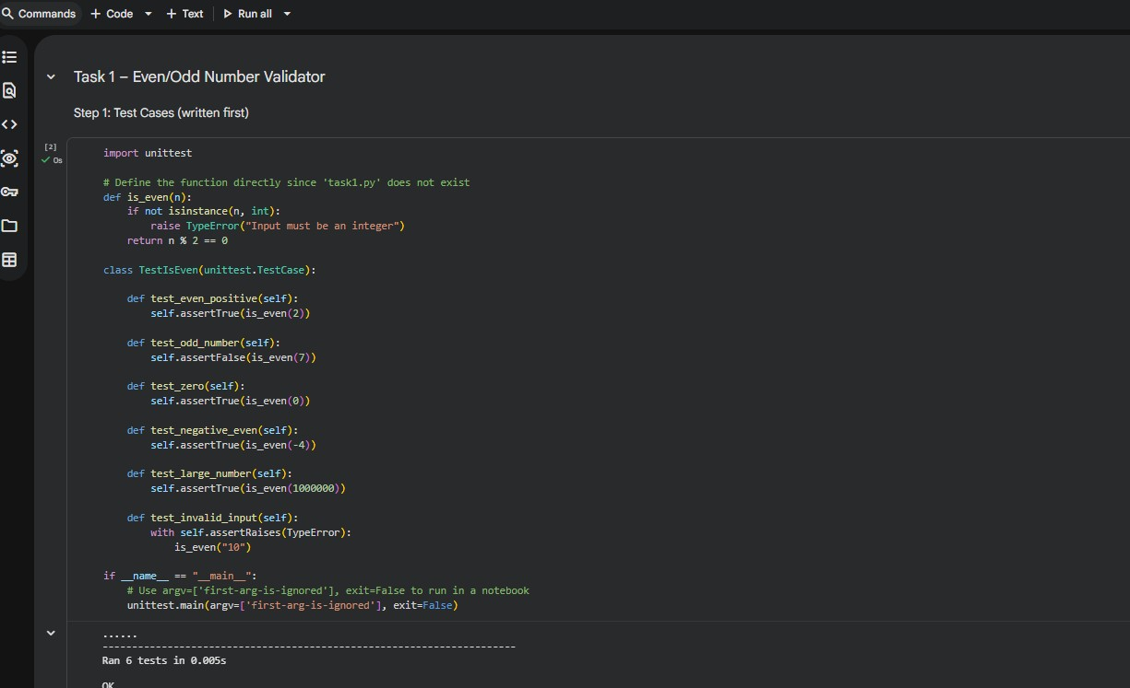
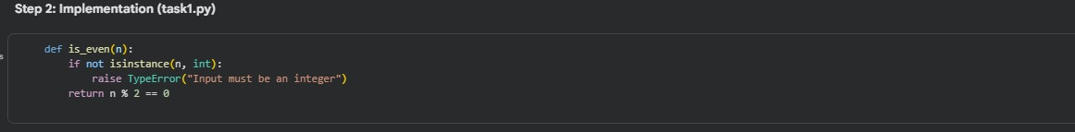

String Case Converter

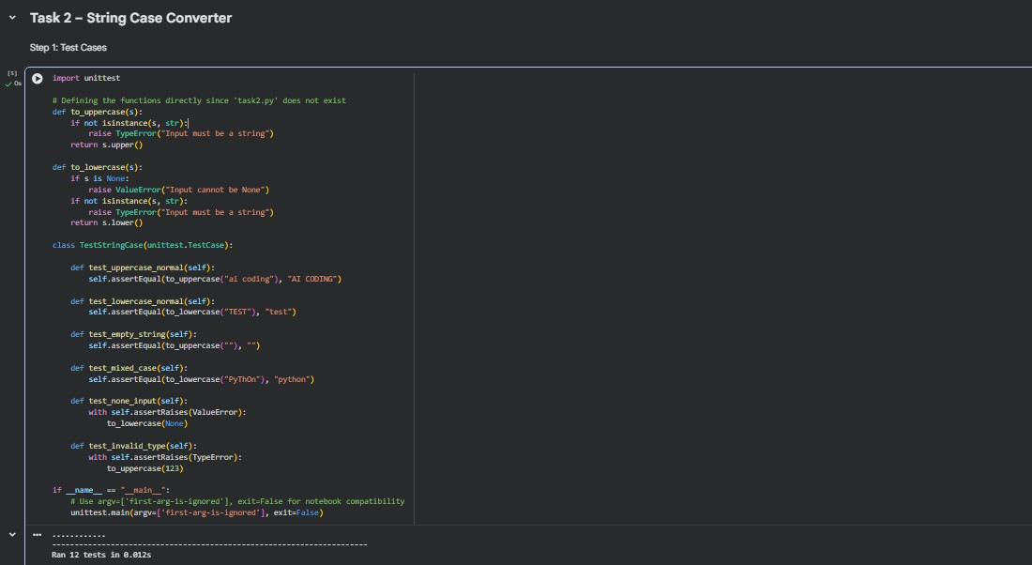
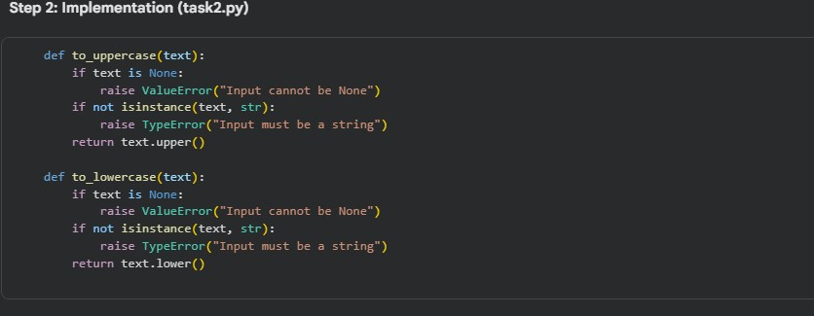

List Sum Calculator

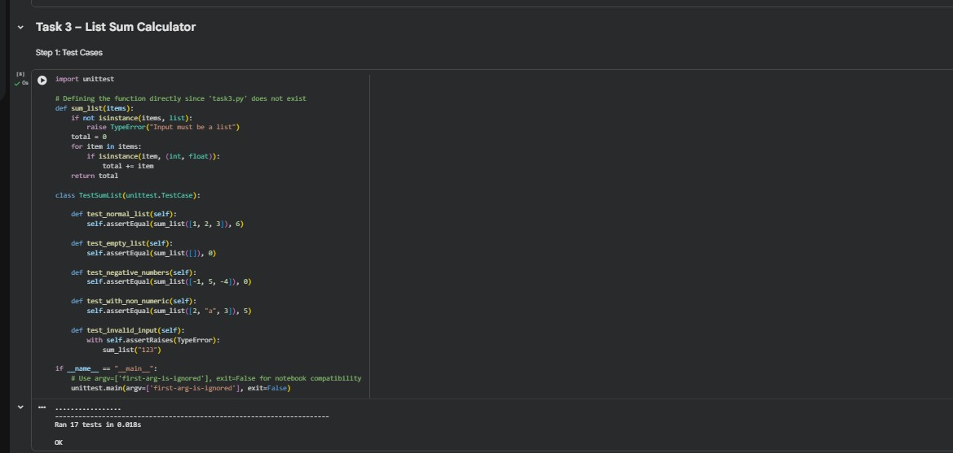
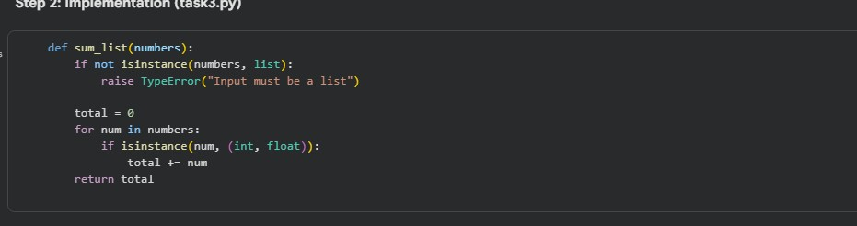

Student Result Class

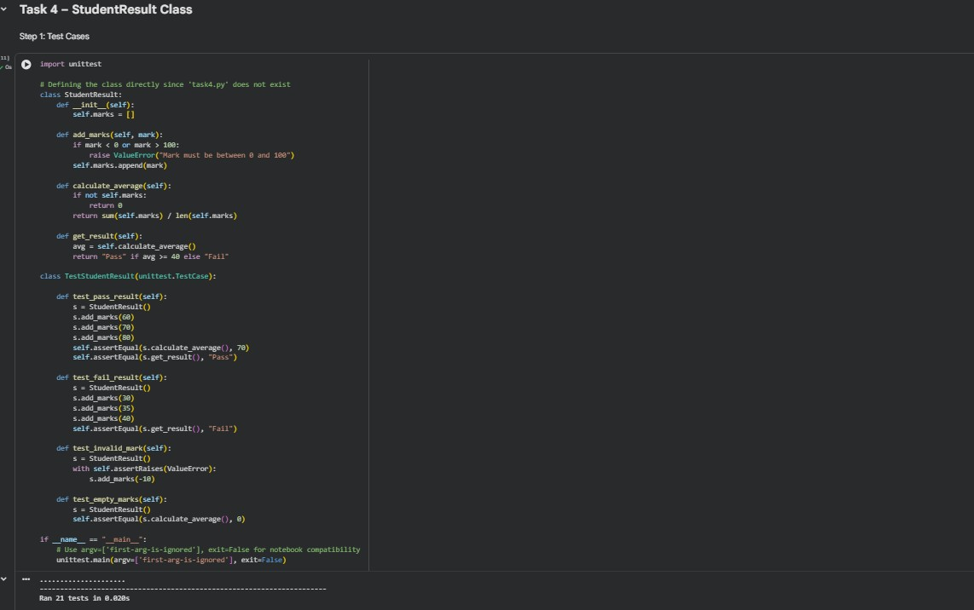
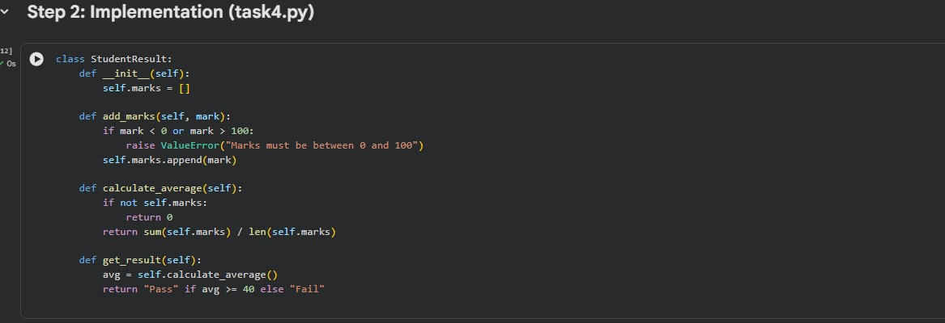

Username Validator

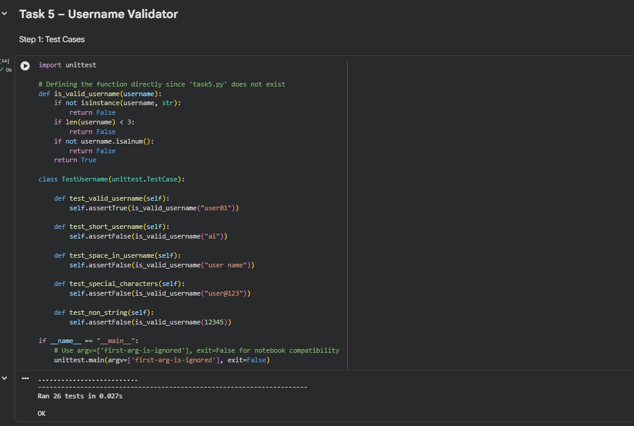
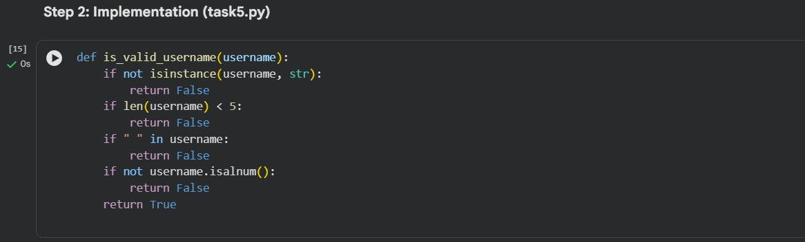
Lab Outcomes Covered
- Test cases written first (TDD style)
- Input validation & error handling
- Edge cases: empty, None, negative, large values
- unittest usage
- Clean and reliable implementations

